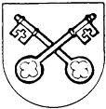
SALESBURY PARISH COUNCIL

Chairman: Cllr M Wood Clerk: L Lund
20 April 2022

You are invited to attend the Annual Meeting of Electors which will be held at the Salesbury Memorial Hall on Monday 25 April 2022 at 7.00pm.

Lesley Lund
Clerk to the Council

- Apologies for absence

- Chairman’s report

- To note the minutes of the Annual Meeting of Electors held on 4 May 2021 as no electors of the parish attended and any updates.

- Any business brought to the meeting by the Electors of Salesbury/Copster Green.

