SALESBURY PARISH COUNCIL
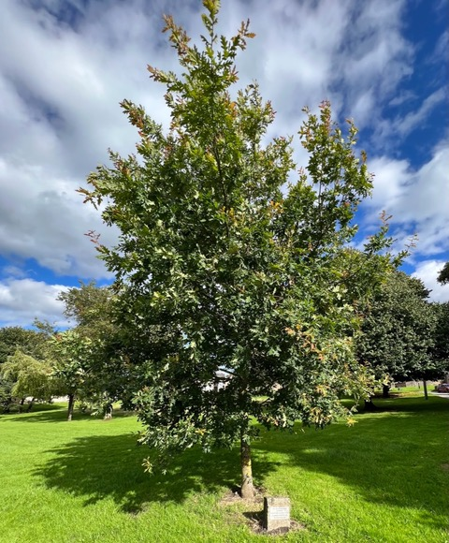
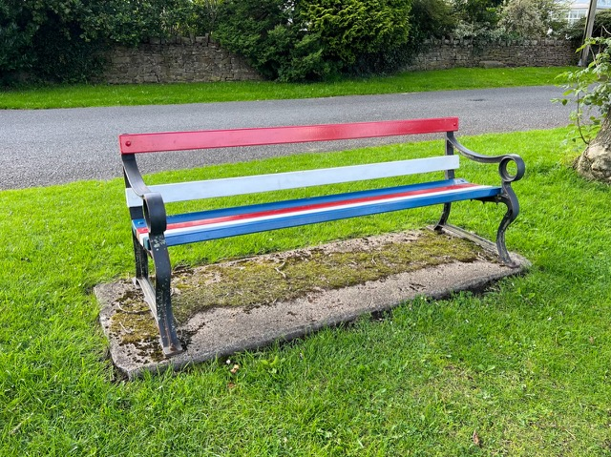
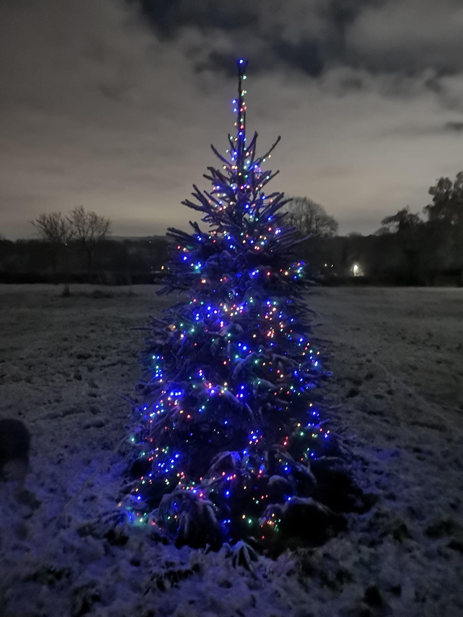
NEWSLETTER 2023

Cover photos (clockwise from top) – The Memorial Tree, Copster Green; Red, White and Blue bench painted by Graham Henderson for the Queen’s Platinum Jubilee 2022; Christmas Tree on Hazelmoor, Salesbury, December 2022

CHAIR'S REPORT 2022/2023

Welcome to the 2023 Newsletter where we share with you examples of the work carried out by the Parish Council during 2022/23 and update you about our plans for the next 12 months.

Following the resignation of Janet Westwell from the Council on 26th March 2022, Chris Booth officially joined us on the 12th December 2022. In May this year we had elections to elect Parish Councillors for the next 4 years, as a result Janet Westwell and Tim Westwell were successful in the election, both of whom have previously served on the Council and are welcomed back.

Sadly, Graham Henderson who was also voted back on to the Council resigned his position in July. The vacancy was quickly filled when Maggy Howells was successful in being re-elected in an uncontested election.

The current Councillors are:
Chris Booth email: cllrchrisbooth@gmail.com
Maggy Howells (Vice Chair) email: cllrmhowells@gmail.com
Janet Westwell email: cllrjanetwestwell@gmail.com
Tim Westwell email: cllrtwestwell@gmail.com
Mike Wood (Chair) email: cllrmwood@gmail.com
Parish Clerk:
Lesley Lund email: salesburypc@gmail.com

We didn’t have the best start to the year as unfortunately our website was deleted in late March. As a result, the Council incurred significant additional costs in order to get a replacement site up and running. This was made up of an honorarium to the Clerk (who is the only employee of the Council), to compensate her for the significant amount of time she spent trying to rectify the situation. I would also like to thank HugoFox, our website provider, for all the detailed background information they gave us and for their help and support in getting the site back up. Around the same time, we also had two large Freedom of Information (FOI) requests. These were successfully dealt with, but again took a substantial amount of additional time for our Clerk.

Very recently we had one formal complaint about the 10% increase in the precept. This was heard by the Council at a special meeting with the complainant. Taking into account the planned Parish Council Projects, the outcome was that the Council stood by its decision.

I would like to record my thanks to all the residents who helped and supported us during the year. Special thanks must go to Phil Bell who has turned out with not only his muscle but also his skill and use of his chainsaw, strimmer, lawnmower, leaf blowers etc. Thanks also to Sue Atkinson who spent many hours helping us dig, clear debris and also provided us and all fellow helpers with tea/coffee/bacon sandwiches and also for the popular small community book swap she runs from her front garden during the summer.
We recently sent out our Annual Survey for 2022/2023, we had 37 returns with many of them giving us some excellent ideas for future projects. We were very pleased to see that the vast majority of respondents think that the Parish Council gives good value for money. Thanks to all who took the time and effort to complete the survey, it gives us a fantastic insight into what residents are thinking and what you want to see in the future. Details of the results of the survey can be found later in this Newsletter.
All Parish Councillors are volunteers who freely give up their time to endeavour to enhance the Parish we live in as best as we can. I would like to take this opportunity to give a massive and sincere thank you to fellow Councillors who did such an amazing job during the past year - Chris Booth, Chris Goodwin, Graham Henderson and Maggy Howells along with our Clerk, Lesley Lund. It was both an honour and pleasure working with you all.

If you would like any further background to any Parish Council activities, please visit our website or speak to any Councillor, we are here to serve you all. The next Councillor Surgery is on Saturday 16 December 10-12 am – brews and biscuits will be served in the first floor conference room at Salesbury Memorial Hall – if you can’t make the stairs for any reason then please contact the Clerk and we will make alternative arrangements for you.

Very Best Wishes
Mike Wood

HAZELMOOR- A BIOLOGICAL HERITAGE SITE

Following an ecological survey by Lancashire County Council, Hazelmoor Common between St. Peter’s Church and The Hazels was found to be very special indeed. It is such a brilliant example of biodiversity and grassland that it is now designated as a Biological Heritage Site.
Salesbury Parish Council are now in the process of commissioning an information board to let people know about the importance of this area and the wide variety of plant species that can be found there. Hopefully when local residents and visitors are aware of just how unique this common is, they will treat the common with more respect. We really are very lucky to have this area on our doorstep and we were all amazed with the results of the survey. If you would like a copy of the original survey, please contact Maggy (cllrmhowells@gmail.com).

Right now we are wondering if there is a talented local woodworker who would be willing to volunteer to make a surround and stand for the board? We would of course supply/cover the costs of all the materials. Below is an example of the sort of board we are looking to create.
We are also looking for someone to illustrate 8 of the plants and flowers which occur on Hazelmoor. Enquiries have been made with commercial artists but it would be lovely if we were able to ‘keep it local’.
If you feel you have the skills necessary, please contact either Chris cllrchrisbooth@gmail.com or Maggy cllrmhowells@gmail.com. We would love to hear from you.
Chris & Maggy

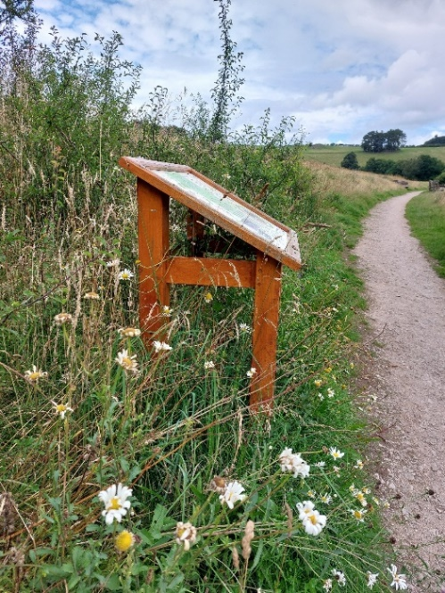

BUS FARE CAPS – BREAKING NEWS!!!
The current £2 bus fare cap was set to run until 31 October 2023, when it was due to increase to £2.50 for single tickets. We are delighted to tell you that this decision has been overturned and the price cap will remain at £2 until 30 November 2024, with other discounts guaranteed until at least March 2025.

This price is valid on almost all our local buses, including many to Manchester, Liverpool and into Yorkshire, for example the “WitchWay” services to Manchester and the 280 from Preston through to Skipton. Sadly school only services are excluded. The discount scheme is funded by the government as part of the Bus Service Improvement Plan which has up to £200million available to subsidise the buses. This is a way of keeping rural, otherwise little-used services going for the benefit of all.
Weekend and evening ticket discounts are also available (not on Blackpool Transport services except services 74 and 75) with evening tickets costing just £1 for any journey, after 7pm and a weekend offer where you can buy a Saturday day ticket and get the equivalent Sunday travel for free.

Of course, anyone receiving State Pension can apply for a pass (www.freedom-pass.co.uk) for free travel after 9.30 on weekdays and anytime at weekend and Bank Holidays. This pass only covers England, so remember not to try to use it in Wales or Scotland!
What a bargain, to say nothing of all the benefits of leaving the car at home!

For more information, see
https://www.lancashire.gov.uk/roads-parking-and-travel/public-transport/bus-tickets/
https://www.gov.uk/guidance/2-bus-fare-cap#north-west

Chris Booth & Maggy Howells

NOTICEBOARDS
Having helped to conduct the recent Annual Survey of residents, I realised that despite living in Copster Green for over 40yrs, I only knew of the location of the noticeboard at Copster Green, near the bottom of Lovely Hall Lane. This tallies with many of the answers we received from the survey, so I am not alone, and I thought that I'd better go exploring.
I went up to St. Peter’s Church and asked a woman walking past if she was local. She was but didn’t know where our noticeboard was! I eventually located it between the lych gate and the large gate by the graveyard. So, to help anyone else, here are a couple of photos on a typical grey day.
Chris
Noticeboard by St. Peter’s Church Noticeboard at Copster Green

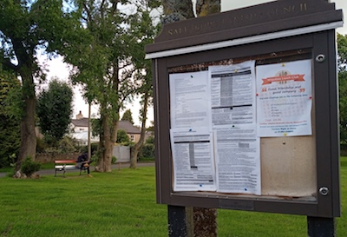
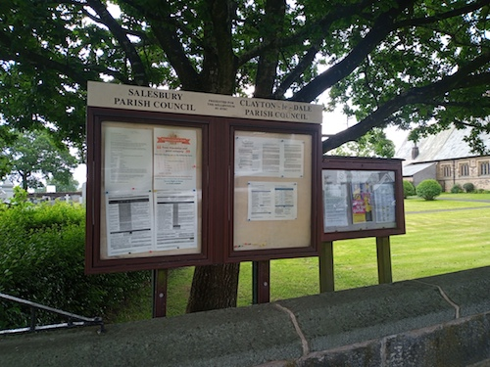

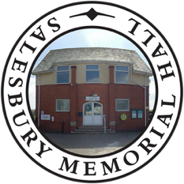
SALESBURY MEMORIAL HALL

Salesbury Memorial Hall is situated at the heart of the villages of Salesbury, Wilpshire and Clayton-le-Dale. The hall was built from funds raised by the local community in memory of the 36 members of the Parish who lost their lives in the Great War of 1914-18. Their names are commemorated on the Roll of Honour in the entrance hall. The hall is now run as a Charitable Trust by a committee of 9 local volunteers who are responsible for the maintenance and future development of the Hall.
The main hall and the two upstairs meeting rooms have recently been refurbished to a high standard. On the ground floor, the facilities comprise of a large, main hall (10m x 18m) and a fully equipped, modern kitchen. New toilet facilities, including an accessible toilet, are also situated on the ground floor. Upstairs there is a large conference/meeting room with a high specification projector and 100”screen. There is also a smaller, adjoining room which can be used separately or for refreshments.
Regular classes and events include:
- Full Service Post Office, every Monday afternoon between 2.30pm – 4.15pm
- KT Fitness classes, every Monday, Tuesday and Thursday from 6pm.
Please contact Katie for more information: www.facebook.com/KTfitnesstraining
- Helen Carter Pilates – every Tuesday morning.
Please contact Helen for more information: helencarterpilates@yahoo.co.uk
- Ladies Badminton every Tuesday afternoon.
Please contact Susan: suejoyce78@gmail.com
- Mixed Badminton – every Wednesday evening.
Please contact Audrey for more information: audrey.pickup@yahoo.com
- Golden Cinema – the last Thursday of the month. Free event for the over 65s.
Please contact Lisa at Right at Home for more information: lisa.tomlinson@rightathome.co.uk
- Ribble Creative Stitchers – who meet the third Friday evening and all day Saturday.
Please contact Jane Holmes for more information: bushbabyjane@googlemail.com
- St Peter’s Mothers’ Union which meets the 4th Wednesday of the month.
Please contact Pamela Bridgford for more information: pamela.bridgford@gmail.com
- Fun with Flowers – frequent workshops throughout the year.
Please contact Sarah Kilbride for further information: sarahanddavekilbride@gmail.com

The hall is fully accessible throughout and offers free WiFi and parking. All of which makes Salesbury Memorial Hall the ideal venue for local interest groups, private parties, wedding receptions, business meetings and community events.
To book your event please email Annette Patterson at annette8cg@gmail.com
Salesbury Memorial Hall is currently running a SAFE campaign to enable improved safer access to the Hall and carpark. For more information please see https://www.salesburymemorialhall.com/safe-campaign
Salesbury Parish Council is pleased to support this campaign, if you would like to join us in this, please consider donating at https://checkout.justgiving.com/c/3398249 or speak to one of the Trustees

OPPORTUNITY FOR PARISH HANDY PERSON/LENGTHSMAN

Salesbury Parish Council is currently discussing the establishment of a position of a Parish Handy Person. If this is a role that appeals to you, we would like to invite you to submit an application/tender which must include:
- An hourly rate quotation inclusive of all associated costs e.g. VAT, PPE etc (excluding materials which will be funded directly by the Parish).
- An outline of your experience
- Details of insurance cover
- Any other information you want the Council to be aware of in making its decision

Terms of the appointment will be on an ad hoc hourly self-employed basis, using your own equipment. You will also be required to have your own public liability insurance.
Duties to include, but are not limited to, litter picking, path clearance, painting of signs and milestones, maintenance of benches, trimming/pruning of shrubbery, clearance of ditches, assistance with the erection and taking down of Christmas trees.

Subject to approval by the Parish Council, the contract is expected to commence 1st December 2023 until 31st May 2024.
Apply
By post to Lesley Lund, 5 Hollowhead Close, Wilpshire BB1 9LE
By email to salesburypc@gmail.com
Closing date: 5pm 15 November 2023

UP AND ACTIVE – RVBC
FREE WEEKLY WELL BEING WALKS

Join the group for a variety of guided walks which aim to suit a range of fitness levels. Explore our beautiful countryside, meet people and enjoy a little bit of head space.
For more information contact Ribble Valley Borough Council on 01200 414586 or visit the website at upandactive.co.uk

SAFE TRADER SCHEME
Are you looking for a reputable trader?
Trading Standard’s Safe Trader Scheme can help you find reputable traders for property repairs, home improvements, gardening services, mobility aids and other services around the home.
For further information call 0303 333 1111 or visit www.safetrader.org.uk or safetrader@lancashire.gov.uk
Local Facebook groups can also be a good way to find locally recommended traders & services but do remember to check their insurance details and always ask for and follow up references.

WHAT POWERS AND DUTIES DO PARISH COUNCILS HAVE?
Parish Councils in England have a variety of powers and duties, all of which impact directly on the community.
Below are just some of the powers and duties that fall within the remit of Salesbury Parish Council:
General Spending - Parish Councils can spend a limited amount of money on anything they deem of benefit to the community that is not covered by the other specific responsibilities described in this list.
Donations- the Parish Council may make donations to groups (not individuals) providing services or benefits to residents of the parish.
Highways - Whilst Lancashire County Council is responsible for public highways, The Parish Council also has the right to be involved with lighting, parking places, discussions about new roads and road widening, traffic signs and other notices, tree planting and verge maintenance.
Land - acquisition, maintenance and sale of land owned by the Parish Council (Salesbury Parish Council does not currently own any land or buildings)
Legal proceedings - power to prosecute and defend any legal proceedings in the interests of the community, power to take part in any public enquiry
Litter - provision of litter bins through Ribble Valley Borough Council and support for any anti-litter campaigns
Planning - right to be notified and make comments on any planning applications in the area
Public Rights of Way - footpath and bridleway maintenance (in conjunction with Lancashire County Council and landowners)
Provision and maintenance of public seats and benches
Signs - danger signs, place names and information signs
Tourism - the Parish Council may make financial contributions to any local tourist organisations allowed
Traffic Calming
Protection of Common Land – Salesbury Parish Council collaborates with Ribble Valley Borough Council who are the legal managers of the common land within the parish.
​

RESULTS OF 2023 ANNUAL SURVEY

One copy of the survey was delivered to every property within the Salesbury Parish Council boundaries and of the 193 surveys delivered, 37 surveys were completed and returned. This was a response rate of almost 20%, slightly down from last year.
Q1 Protection of Common Land – the majority of respondents said YES to the installation of stones or fencing to protect the Commons rather than bushes or trees.
Q2 Drop-In Surgeries – the majority of respondents thought the surgeries should continue and preferred these to be face-to-face meetings.
Q3 Christmas trees – the majority of respondents thought that the Parish Council should continue to provide Christmas trees.
Q4 Working Groups – over 25% respondents said they would consider joining a working group depending on their circumstances and the topic
Q5 Cricket Club/Hazelmoor – The majority of respondents were in favour of putting large boulders along the track to prevent parking on the Common Land.
Q6 Additional Noticeboard – the majority of respondents would like an additional noticeboard and knew of the location of the present noticeboards.
Q7 Suggestion Box – there were an even number of replies for and against a suggestion box being placed next to the noticeboards.
Q8 Precept – the majority of respondents thought that Salesbury Parish Council represented good value for money
Q9 Budget and Plans – various suggestions were received; these are included in the list below.
Q10 Communication – Some respondents thought it was a good idea to use social media to communicate although the majority of respondents preferred to receive paper copies of leaflets and notices.
Q11 SPID [Speed Indicator Device] – The majority of respondents were interested in attending a presentation on SPIDs

Comments and Suggestions received
A number of comments and suggestions related to actions outside of our remit. Some of these were the responsibility of other local Parish Councils whilst others are the responsibility of Ribble Valley Borough Council (RVBC) and/or Lancashire County Council (LCC). Subject to approval at a meeting, we will look to pass these comments on to and/or collaborate with the appropriate authority (in brackets) in due course.
- Not all residents are computer literate and prefer paper information sheets and drop-in surgeries.
- Lovely Hall Lane verge - fill in holes and tidy up grass verges (LCC)
- Fill potholes with permanent filler (LCC)
- Speeding and parking on Lovely Hall Lane – particularly at school drop off times - emergency service vehicles would not be able to get through – need one way (Police and LCC)
- Would like local allotments
- Areas of the Common Land at Copster Green to be left wild (RVBC)
- Rare Ragged Robin found growing on the Green
- Wild Flower areas if possible (RVBC)
- Thank you for all the work that goes on much behind the scenes
- Request for Grit Box top of Park Gate Row [not bright yellow] (LCC)
- Request for Grit Box at bottom Lovely Hall Lane (LCC)
- A big thanks to the PC for the tidying up of the Middle Green.
- Thanks to people who maintain the planters.
- Request for electric socket on the Green (RVBC)
- Request for a Christmas Tree to be planted for annual use (RVBC)
- Install additional dog poo bins on school car park and by Yu (RVBC)
- Replace damaged dog poo bins at Copster Green and on Hazelmoor (RVBC)
- Increase parking on Copster Green for those with no drive/garage (RVBC)
- Young people’s newsletter
- Thanks to previous Council members and clerk– be proud of your achievements
- Public footpaths to be maintained and accessible for all, replace missing signs
- Educate people of the value of the Greens and Common Land
- Thanks everyone for all your hard work last year. Looking forward to this continuing
- A59 Traffic Issues (LCC)
- Lighting around the Green during Winter (LCC/RVBC)
- Protection of Natural Environment
- Traffic Calming (LCC/RVBC)
- Litter on Lovely Hall Lane
- Car parks not adequate (LCC/RVBC)
- We seem to have a good active PC now
- Installation of benches on wooded areas of Lovely Hall Lane
SALESBURY C.E. PRIMARY SCHOOL
Providing High-Quality Teaching and Learning for children from aged 3 -11
Contact - 01254 244580 office@salesbury.lancs.sch.uk

September is an exciting time in the life of a school - a great time to reflect on the year that has passed and recall lots of happy memories! It is also a time of anticipation as our school diary begins to fill with lots of exciting times ahead. We aim to make learning memorable for all our pupils and no two weeks are exactly the same!
We made the most of the weather last term and took lots of our learning outdoors. Each year, we have a special week where we remind ourselves what beautiful surroundings we have for our school by having our ‘Learning from the Land Week’ Each year, has a different focus. This year, it was entitled ’It’s up to us!; We used a lovely book to inspire children to take responsibility and ownership of our earth and encouraged children to create a TerraCarta—the Earth’s Charter. The book inspired some beautiful artwork and this year each class spotted a local area which needed improving by weeding, litter-picking, clearing or developing and they worked hard to make a difference. Each class also chose to create a space in our school grounds - they could choose from creating a space which encouraged action or quiet. We have some amazing new spaces in our school now and our Year 6 left a lovely legacy by creating a Sanctuary - an outdoor space for reflection or prayer!
Our new school year was kick-started by a special week too! Each class chose a book to inspire learning - writing, artwork, drama and cooking!
We have now started our historical focus and classes are looking forward to field visits to complement their learning. This term, we have visits planned to Blackburn Museum to study the history of toys, Bankfield Museum to look at the history of Fashion, World Museum, Liverpool for a spot of mummification, the Beatles Museum to enhance the study of the history of music, the Titanic Museum and a visit to York as part of a study on Transport. These experiences create lasting memories and bring learning to life!
Last term, we asked our parents what they would like to know about—they told us to share how we taught Maths and English at school. Well, what better way to learn than coming ‘Back to School’! Parents have now been invited to join in a lesson with their child— I do hope they try really hard and behave well!
JOIN OUR ONLINE SOCIAL COMMUNITY
www.facebook.com/SalesburyCEPrimary www.salesbury.lancs.sch.uk
FRIENDS OF SALESBURY SCHOOL FORTHCOMING EVENTS
- Critters - Interactive event with reptiles, bugs & critters!
- School Discos
- Quiz Night
- Christmas Fair
- Christmas Jumper and Nativity Costume Sale

CURRENT EXTRA-CURRICULAR CLUBS AT SALESBURY
Choir Netball
Drumming Dance
French Cross Country
Globe Trotters Latin
School Council Eco Council
History Computing
Girls Cricket Tuesday Foodies!

USEFUL CONTACTS

Salesbury Parish Council
The current Councillors are:
Chris Booth email: cllrchrisbooth@gmail.com
Maggy Howells (Vice Chair) email: cllrmhowells@gmail.com
Janet Westwell email: cllrjanetwestwell@gmail.com
Tim Westwell email: cllrtwestwell@gmail.com
Mike Wood (Chair) email: cllrmwood@gmail.com
Parish Clerk:
Lesley Lund email: salesburypc@gmail.com

Website: http://www.salesburypc.org.uk/

Ribble Valley Borough Council
Council Offices, Church Walk, Clitheroe. BB7 2RA
Tel: 01200 425111
Website : https://www.ribblevalley.gov.uk/

Local Councillor: Louise Edge (cllr.louise.edge@ribblevalley.gov.uk)

Lancashire County Council
PO Box 78, County Hall, Fishergate, Preston. PR1 8XJ
Tel: 0300 123 6701
Website : https://www.lancashire.gov.uk/

Local Councillor: Alan Schofield (alan.schofield@lancashire.gov.uk)

Love Clean Streets
Download the app to your computer, laptop or smartphone to report issues relating to potholes, flooding, pavements, highways, road signs, winter gritting and much, much more.
For more information go to https://www.lancashire.gov.uk/roads-parking-and-travel/report-it/report-it-on-the-go/
Or simply download the app via Google Play or the Apple App Store
Don’t just grumble…report it!

